**Build A Linux Web Server**

**Project Name:** Build a Linux Web Server

For this project, we will be building a web server using Linux that will be useful in running our own websites. The project is also known as the LAMP stack which stands for “Linux, Apache, MySQL, PHP/Pearl/Python”. Linux will be our operating system, Apache will act as our web server software, MySQL used for database management, and PHP/Pearl/Python for programming.

**Motivation:** Updating the APT package repository cache ensures your system remains secure and up-to-date, while installing and configuring MySQL/MariaDB provides a reliable and scalable database solution for your applications, enhancing performance and data management capabilities. These tasks are crucial for maintaining a robust and efficient IT infrastructure.

## Area of Work: Updating APT Package Repository Cache

### Installing and Configuring MySQL/MariaDB

## Updating APT Package Repository Cache: The following command is used for updating the APT package Repository Cache

## $ sudo apt update

## 

By using the above command we have updated the apt package.

**Installing and Configuring MySQL/MariaDB:** Now, installing MariaDB server and client packages from the official package repository of Debian 10 with the following command:

## $ sudo apt install mariadb-server mariadb-client

## By running the following command we get the following result:

## To confirm the installation, press Y and then press <Enter>.

## 

## The APT package manager will download and install all the required packages.

## At this point, MariaDB server and client packages will be installed.

## Now, check whether ****mariadb**** service is running with the following command:

## $ sudo systemctl status mariadb

## As you can see, the ****mariadb**** service is running. It’s also ****enabled**** to automatically start on system boot.

## 

## 

If in any case, **mariadb**service is not running, then start the service with the following command:

**$ sudo systemctl start mariadb**

Now, run the following command to set a **root** password for MariaDB:

**$ sudo mysql_secure_installation**

## Press **<Enter>**.

## Now, press **Y** and then press **<Enter>**.

Now, type in your **root** password and press **<Enter>**.

Type in your **root** password again and press **<Enter>**.

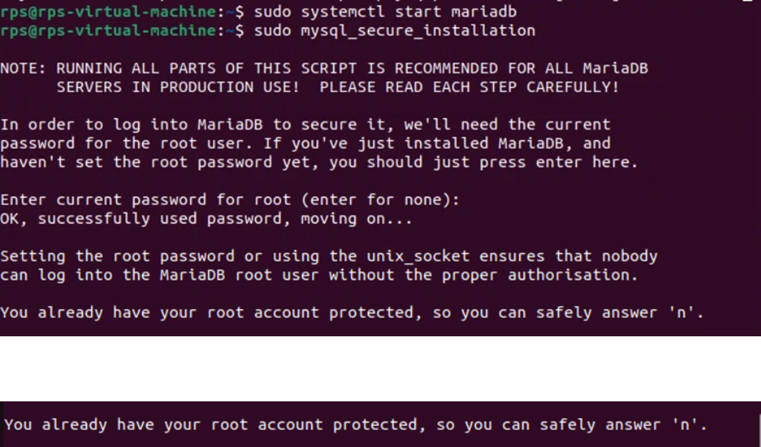

Press **Y** and then press **<Enter>** to remove anonymous users.

If you don’t want to allow **root** login remotely, press **Y**. Otherwise, press **N**. Then, press **<Enter>**.

Now, press **Y**and press **<Enter>** to remove test database.

Now, press **Y** and then press **<Enter>** to reload the privilege table.

MariaDB should be configured.

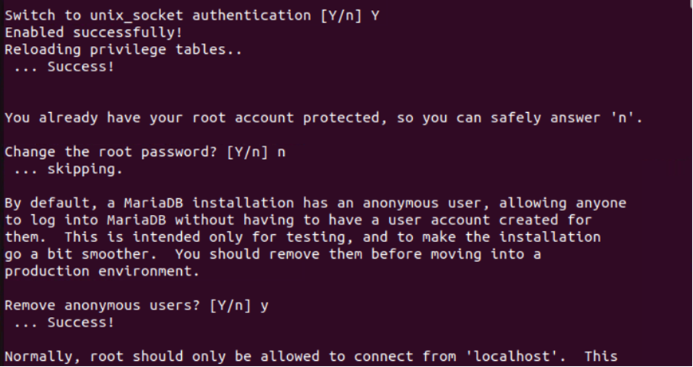

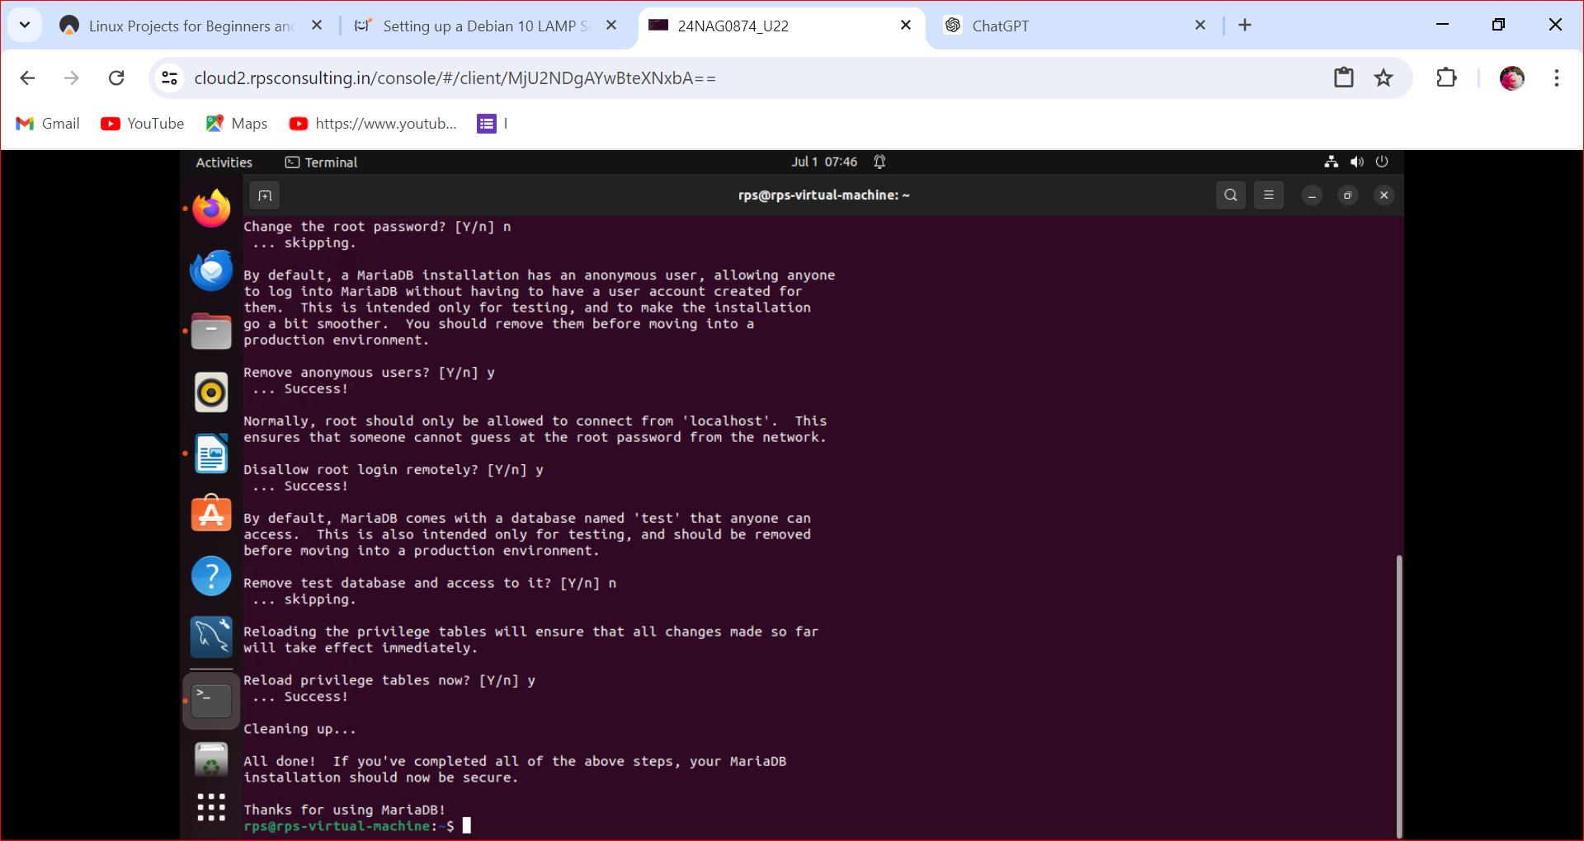

**Purpose of your work:**

Updating APT Package Repository Cache

Updating the APT (Advanced Package Tool) package repository cache is necessary to ensure that your system has the most current information about available software packages and their versions. Here’s why it’s important:

1. **Access to Latest Packages**: Software repositories constantly update with new versions of packages that fix bugs, enhance features, or patch security vulnerabilities. Updating the cache ensures that your system knows about these updates and can offer them to you when you run package management commands like apt-get update or apt update.
2. **Security Updates**: Keeping your package repository cache updated is crucial for receiving security updates promptly. Security patches often come as updates to existing packages, and unless your repository cache is current, your system won’t be aware of these critical updates.
3. **Dependency Resolution**: APT uses the repository cache to resolve dependencies when installing or upgrading packages. If the cache is outdated, APT may not be able to accurately determine which versions of packages are compatible with each other, potentially leading to installation issues or broken dependencies.
4. **Package Information**: The cache contains metadata about packages, such as descriptions, dependencies, and package locations. This information is essential for browsing available packages and understanding what each package does before installing it.
5. **Efficiency**: Updating the repository cache regularly can improve the efficiency of package management operations. APT doesn’t have to download package information every time you want to install or update software, as it can quickly refer to the local cache.

In summary, updating the APT package repository cache ensures that your system is up-to-date with the latest software versions, security patches, and package information, thereby enhancing both the security and functionality of your system.

## Installing and Configuring MySQL/MariaDB:

Installing and configuring MySQL or MariaDB, which are popular relational database management systems (RDBMS), is essential for various reasons, especially in the context of web development, application deployment, and data management. Here’s why it’s necessary:

1. **Data Storage and Management**: MySQL and MariaDB are robust RDBMSs designed to efficiently store, retrieve, and manage relational data. They provide structured storage capabilities that are crucial for organizing and accessing data in a predictable and efficient manner.
2. **Scalability**: These databases support scalable architectures, making them suitable for both small-scale applications and large-scale enterprise solutions. Proper configuration allows you to optimize performance and handle increased data volumes as your application or business grows.
3. **Reliability and Durability**: MySQL and MariaDB are known for their reliability and data integrity features, including support for transactions and ACID (Atomicity, Consistency, Isolation, Durability) compliance. Configuring them properly ensures that your data is stored securely and can withstand failures without compromising consistency.
4. **Performance Optimization**: Configuring MySQL or MariaDB involves tuning various parameters such as memory allocation, caching mechanisms, query optimization, and storage engine selection. Proper configuration can significantly improve database performance, reducing latency and enhancing response times for applications.
5. **Security**: Installing and configuring MySQL or MariaDB includes setting up authentication mechanisms, user privileges, and access controls to protect your data from unauthorized access or malicious activities. This is crucial for maintaining data confidentiality and integrity.
6. **Compatibility and Ecosystem**: MySQL and MariaDB have extensive community support, a rich ecosystem of tools and libraries, and compatibility with various programming languages and frameworks. This makes them versatile choices for integrating with different applications and environments.
7. **Backup and Recovery**: Proper configuration includes setting up backup strategies and recovery mechanisms to ensure data availability and continuity in case of hardware failures, human errors, or disasters.
8. **Compliance and Standards**: MySQL and MariaDB adhere to SQL standards, making them compatible with standard SQL queries and practices. This ensures consistency and portability of your database applications across different platforms and environments.

In summary, installing and configuring MySQL or MariaDB is essential for reliable data storage, efficient data management, scalability, performance optimization, security, and compliance with standards. These databases form the backbone of many applications and services, providing a stable and efficient foundation for data-driven operations.

**Software Required:** MariaDB

MariaDB serves several important purposes in the realm of database management and application development:

1. **Relational Database Management System (RDBMS)**:
   * **Data Storage**: MariaDB is primarily used for storing structured data in a relational format, which is ideal for applications requiring complex querying and data relationships.
   * **Data Integrity**: It ensures data integrity through support for transactions and ACID (Atomicity, Consistency, Isolation, Durability) compliance, crucial for maintaining data reliability.
2. **Compatibility and Interoperability**:
   * **SQL Compatibility**: MariaDB is highly compatible with standard SQL (Structured Query Language), making it easy to migrate applications and scripts from other databases like MySQL.
   * **Tooling and Libraries**: It supports a wide range of tools, libraries, and frameworks, ensuring compatibility with various development environments and ecosystems.
3. **Scalability and Performance**:
   * **Scalability**: MariaDB supports scalable architectures, allowing it to handle large volumes of data and increasing demands as applications grow.
   * **Performance Optimization**: It offers various optimization features such as indexing, caching, and query optimization to enhance database performance.
4. **Security**:
   * **Authentication and Access Control**: MariaDB provides robust security features, including user authentication mechanisms, access controls, and encryption options to protect sensitive data.
5. **Open Source and Community Support**:
   * **Open Source**: MariaDB is open-source software, providing transparency, flexibility, and community-driven development.
   * **Community Support**: It benefits from a vibrant community of developers, users, and contributors who contribute to its development, support, and enhancement.
6. **High Availability and Reliability**:
   * **High Availability**: MariaDB supports features like clustering and replication for achieving high availability and ensuring continuous access to data even during hardware failures or maintenance.
7. **Data Warehousing and Analytics**:
   * **Data Analysis**: MariaDB integrates with analytics and reporting tools, enabling businesses to perform advanced data analysis, reporting, and business intelligence.
8. **Cloud and On-Premises Deployment**:
   * **Deployment Flexibility**: It can be deployed both on-premises and in the cloud, providing flexibility in infrastructure choices and deployment models.

In summary, MariaDB serves the fundamental purpose of providing a reliable, scalable, performant, and secure relational database management system that supports a wide range of applications and use cases across different industries and environments.

**Inputs:**

**The following commands are used as the Inputs**

## $ sudo apt update

## $ sudo apt install mariadb-server mariadb-client

## $ sudo systemctl status mariadb

**$ sudo systemctl start mariadb**

**$ sudo mysql_secure_installation**

**Outputs:**

**The following snips demonstrates the outputs**

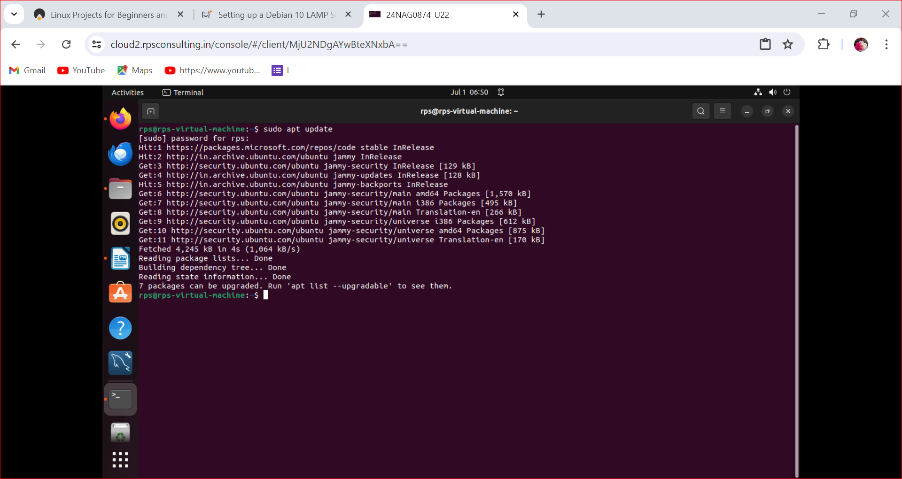

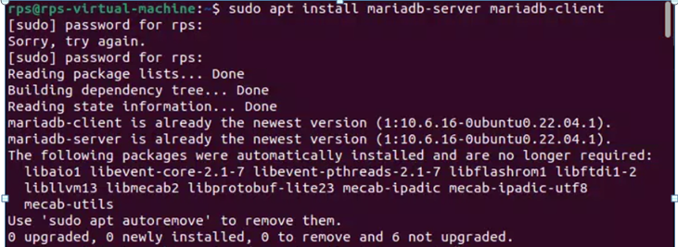

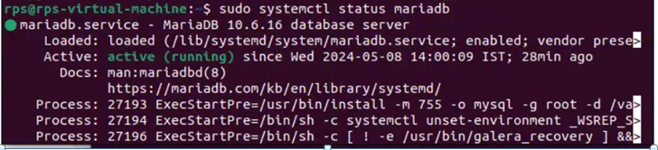

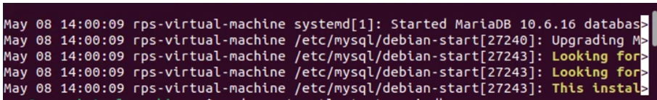





**Development and Testing:**

Developing and testing tasks like updating the APT package repository cache and installing/configuring MySQL/MariaDB typically involves several steps to ensure proper functionality and reliability. Here’s a general approach for each:

### Update APT Package Repository Cache:



#### Development Steps:

1. **Understanding APT Commands**: Familiarize yourself with APT commands used for updating package repository caches. For example, apt-get update or apt update on Debian-based systems.
2. **Script Development**: Create a script (e.g., Bash script) that encapsulates the APT update command. This script can be used for automation or testing purposes.
3. **Error Handling**: Implement error handling in your script to manage scenarios such as network failures or repository access issues.
4. **Logging and Output**: Include logging mechanisms to capture output and errors for troubleshooting and monitoring purposes.
5. **Version Control**: Use version control systems like Git to manage script versions and changes.

#### Testing Steps:

1. **Unit Testing**: Write unit tests to verify that the script executes the update command correctly and handles expected scenarios (e.g., repository changes, cache expiration).
2. **Integration Testing**: Test the script in different environments (e.g., development, staging) to ensure compatibility and functionality across setups.
3. **Edge Cases**: Test edge cases such as minimal network connectivity or repository unavailability to validate error handling and fallback mechanisms.
4. **Performance Testing**: Measure the script’s performance to ensure it runs efficiently without significant delays or resource consumption.
5. **Security Considerations**: Validate that the script does not introduce security vulnerabilities, such as unintended command execution or data exposure.

### Install and Configure MySQL/MariaDB:



#### Development Steps:

1. **Installation Script**: Develop a script that automates the installation of MySQL/MariaDB packages using APT or the appropriate package manager for your operating system.
2. **Configuration Template**: Create a template or script for configuring MySQL/MariaDB settings such as root password, database directories, and initial settings.
3. **Security Configuration**: Include steps to configure authentication, user privileges, and network security settings to protect the database.
4. **Parameter Tuning**: Implement scripts or commands for tuning database parameters (e.g., buffer sizes, cache settings) to optimize performance based on system resources and workload.
5. **Backup and Recovery**: Develop scripts or procedures for setting up backup strategies and recovery processes to ensure data resilience.

#### Testing Steps:

1. **Installation Testing**: Verify that the installation script correctly installs MySQL/MariaDB packages without errors and handles dependencies properly.
2. **Configuration Testing**: Test the configuration script to ensure it correctly applies settings and configurations specified for MySQL/MariaDB.
3. **Integration Testing**: Validate that MySQL/MariaDB operates correctly with applications or services that rely on it, ensuring compatibility and functionality.
4. **Security Testing**: Conduct security testing to verify that configured authentication mechanisms and access controls function as intended, protecting the database from unauthorized access.
5. **Performance Testing**: Measure database performance under various loads to validate tuning parameters and ensure optimal operation.
6. **High Availability Testing**: If applicable, test high availability features such as clustering or replication to ensure database availability and failover functionality.

### Best Practices:

* **Documentation**: Document development and testing procedures, including script usage, dependencies, and configurations.
* **Automation**: Automate deployment and testing processes where possible to ensure consistency and repeatability.
* **Collaboration**: Involve relevant stakeholders such as developers, system administrators, and security teams to review and validate scripts and configurations.

By following these steps, you can develop, test, and validate the functionality and reliability of tasks like updating the APT package repository cache and installing/configuring MySQL/MariaDB, ensuring smooth deployment and operation in production environments.

**Conclusion:**

In short, updating the APT package repository cache ensures access to the latest software updates and security patches, improving system stability and performance. Installing and configuring MySQL/MariaDB provides a robust, secure, and scalable solution for efficient data management and application support, enhancing reliability and compatibility across various environments. Together, these tasks are fundamental in maintaining a secure, efficient, and well-managed system infrastructure.

Top of Form

Bottom of Form